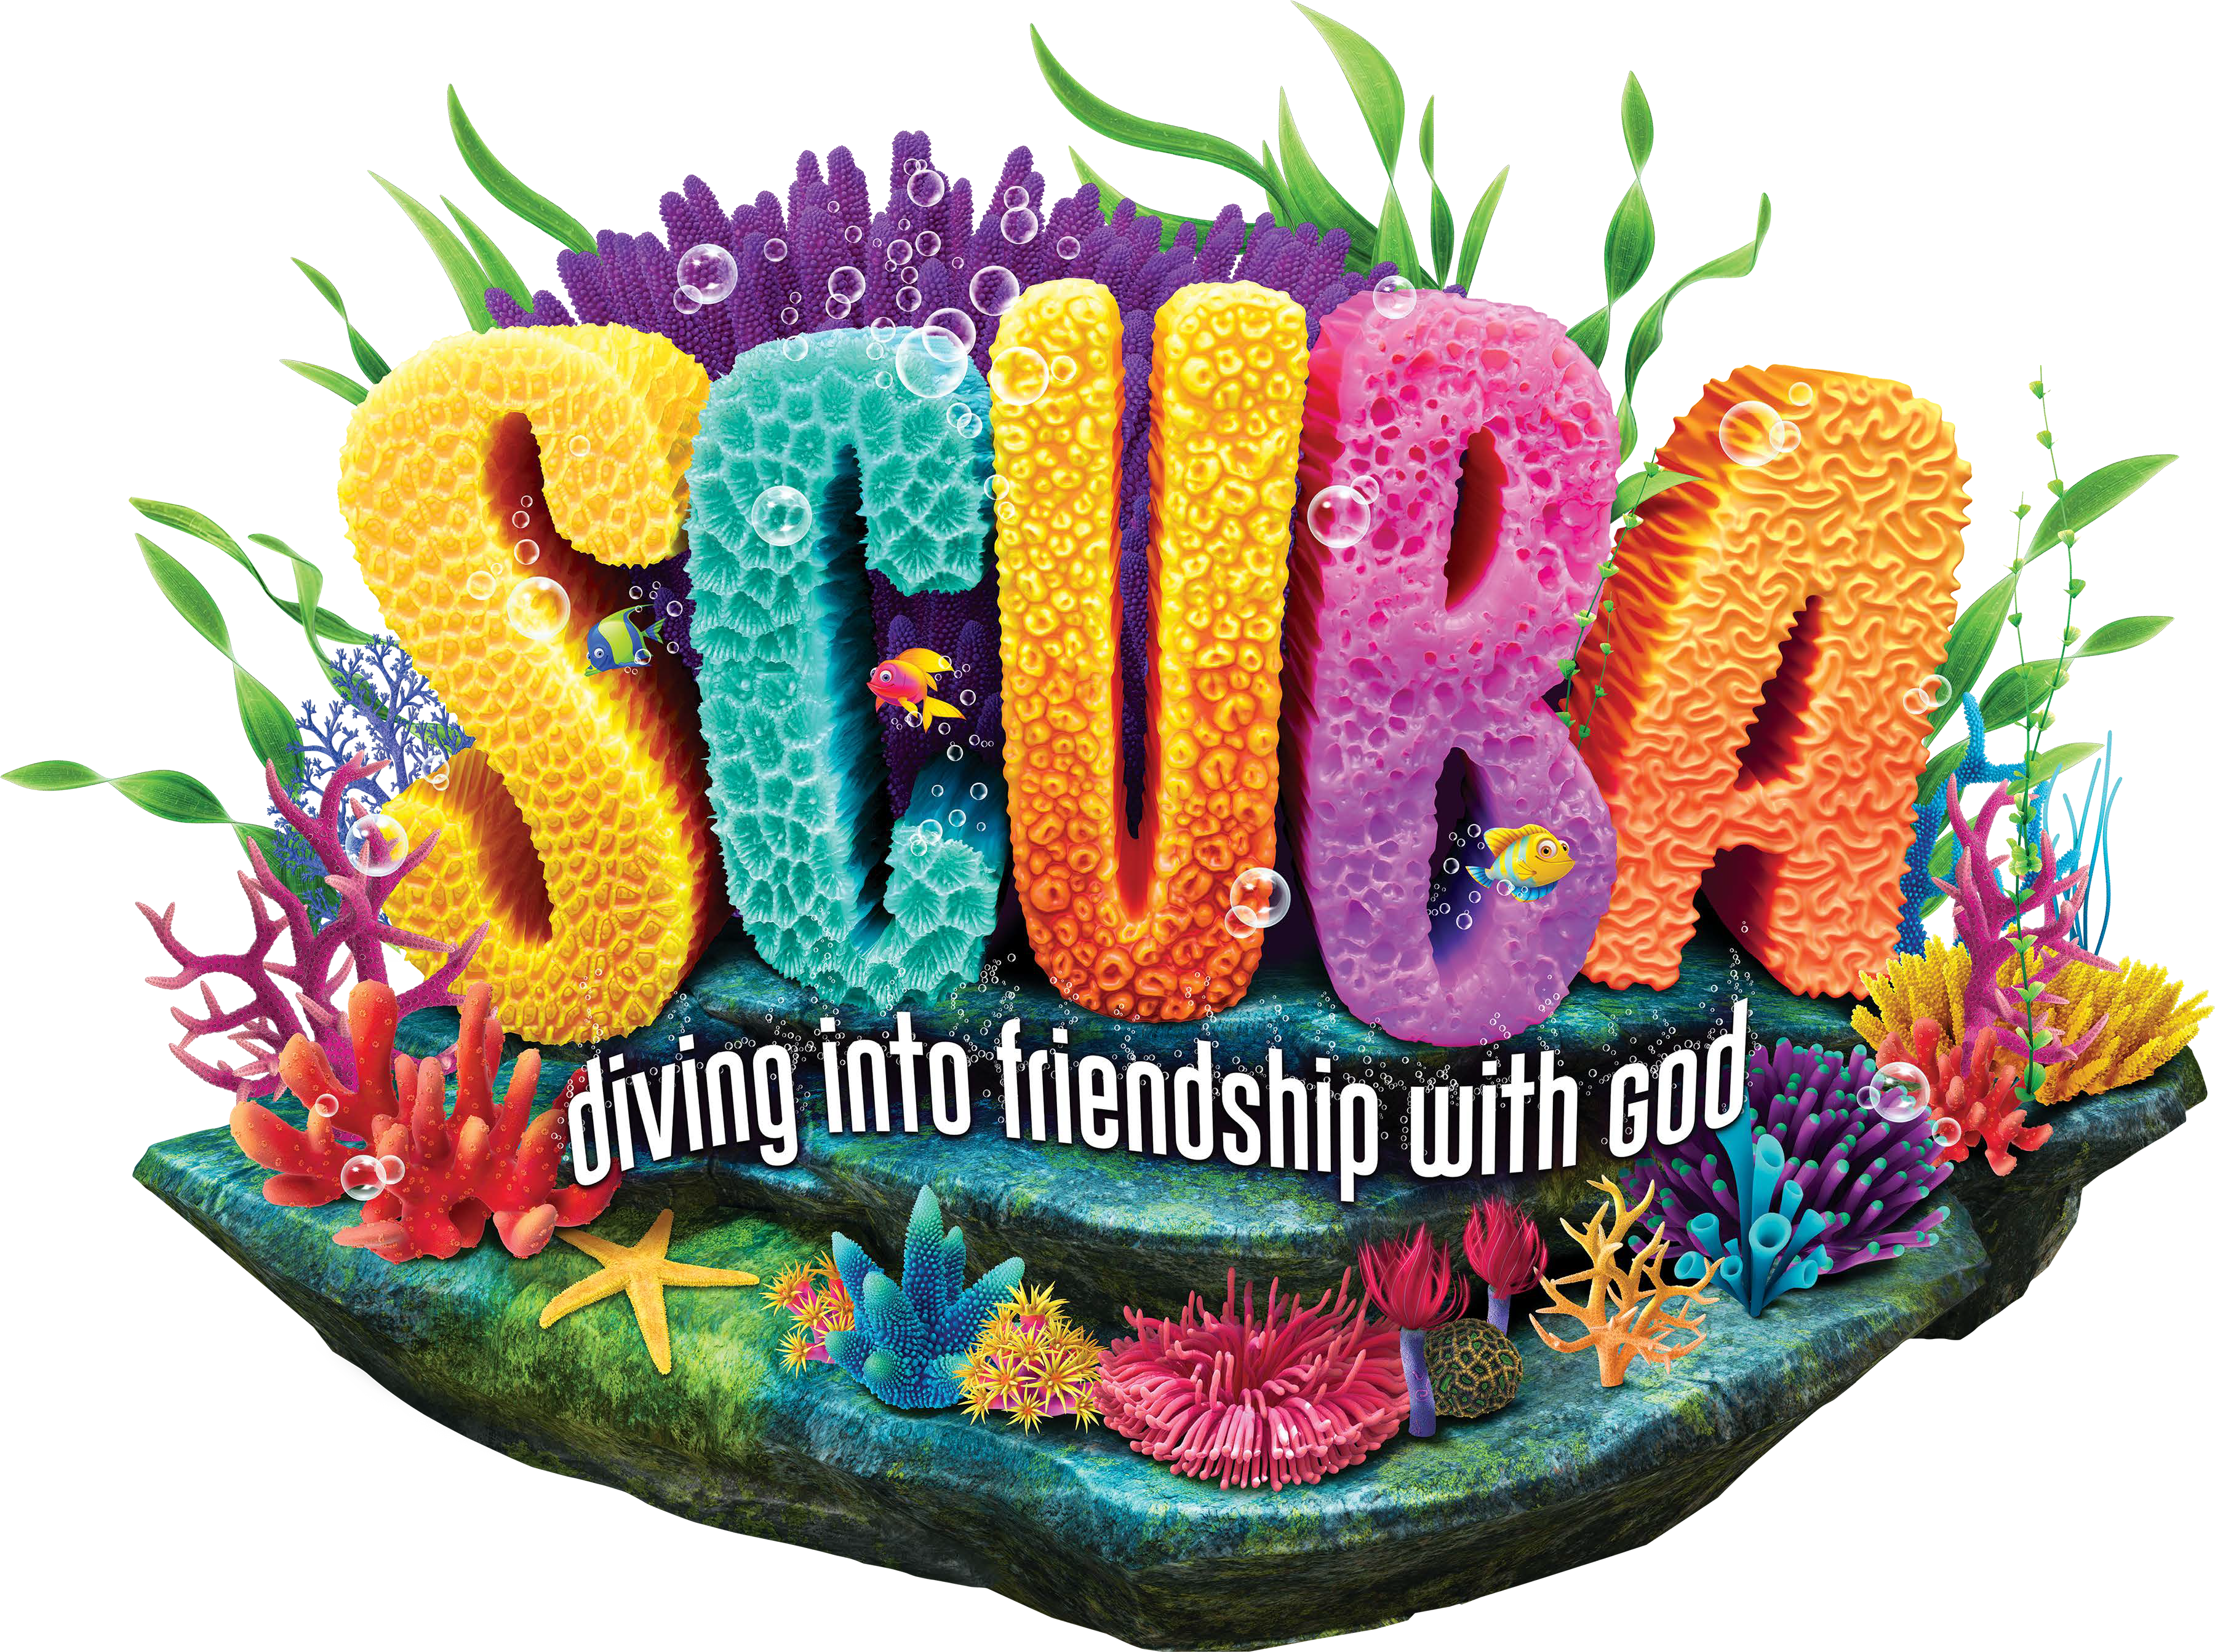
VBS (Student) Registration Form

Student’s Name T-Shirt Size Parent/ Family/Guardian Name
Address

E-mail Address

Phone Numbers: Home Cell Work

Date of birth Age Last school grade completed

Home Church (if any)

Friends of your child at this church

Special Needs/Allergies/Medical Information/Other:

Emergency Contacts
Name Phone

Name Phone

Name(s) of person(s) who may pick up this child from VBS

Photo Release: Church/VBS has my permission to use my child’s photograph publicly in VBS materials. I understand the images may be used in print publications, online publications, presentations, websites, and social media. I also understand that no royalty, fee or other compensation shall become payable to me by reason of such use.

Parent/Guardian’s signature: Date

- - - - - - - (for church use only) - - - - - - -

Assigned to Group:

Are family members helping with VBS? If yes, where?

Save the date for Vacation Bible School!
June 3rd -7th
9:00 AM- 12:00 PM
Ages 4k-rising 5th graders will spend the week diving into friendship with God and will end the week on Friday with an outside Water Day!

Kids will rotate to Monday through Thursday to different stations that will engage them in varieties of ways to connect and experience the Bible lessons for the day. The stations include: Crafts, Deep Bible Adventures, Imagination Station, Sticky Scripture, Reef Rec, Tidal Treats, and will conclude with a Fin-Tastic Finale. On Friday after the Sing and Splash we will end the week with Water Day on the West Lawn to celebrate our fun week of diving deep with God!

If you would like to volunteer please contact:
VBS Director Mary Fran Cook or Tamara Erde

